The Relationship Between Perceived Susceptibility of Contracting an STI and
Frequency of STI Testing Behavior

Team Rose
Ryan Prussack, Logan Spitzley, Vinny Branca, Claire Beddow & Megan Messex
Spring 2020: Health Research Methods
James Madison University

Abstract
The sexually transmitted disease epidemic has created massive health challenges to many Americans, affecting the public at disproportionate rates. Youths aged 15-24 make up roughly half of the twenty million new STI cases that are reported yearly. This study aimed to determine the relationship between perceived susceptibility of contracting an STI and the frequency of STI testing behavior to further understand ways to decrease the rates of STIs in college students. An electronic survey was created by student researchers and distributed to approximately 240 undergraduate JMU students between the ages of 18-22. Each survey was recorded, transferred to SPSS, coded according to items that measured perceived susceptibility, and statistical analyses were conducted. Class standing was measured via multiple choice, gender and sexual orientation were recorded via open-ended responses, and perceived susceptibility was measured with four rank order questions. Results showed no correlation between class standing and frequency of STI testing or class standing and perceived susceptibility of contracting an STI. Women were more likely than men to get tested due to increased concern about their safety related to sexual health, and because women attended more regular doctor’s appointments, compared to men. Additionally, STI testing frequency was positively correlated with a greater perceived susceptibility of contracting an STI, with males displaying higher perceived susceptibility levels than females.

Background
The sexually transmitted disease epidemic poses a massive health challenge to many Americans (Centers for Disease Control and Prevention, 2018). Sexually transmitted diseases show disproportionate rates among different populations. Youths aged 15-24 account for nearly half of the twenty million new STI cases reported annually (Centers for Disease Control and Prevention, 2017). However, of those newly reported STI cases, those contributing to the highest numbers are among young adults aged 20-24 (Bontempi, Bulmer, Danvers, & Vancour, 2009). Many prevention strategies are used to reduce the prevalence of STIs and HIV. Some of these practices include abstaining from sexual intercourse, decreasing the number of sexual partners, and using condoms regularly and correctly (Centers for Disease Control and Prevention, 2018). Similarly, comprehensive sexuality education has been shown to be effective in facilitating these prevention strategies (World Health Organization, 2019).
Along with these practices, getting regular STI screenings and treatments allow sexually active persons to better protect their own health, as well as reduce the spread of infection (Centers for Disease Control and Prevention, 2018). Previous studies have shown that some perceived barriers to getting tested include a lack of knowledge regarding STDs, social stigma, and wait times (Denison, Bromhead, Grainger, Dennison, & Jutel 2017). Similarly, the cost of the test can be a prime barrier to not getting tested for STIs (Keizur, Bristow, Baik, & Klausner, 2019). One study found that men consider (but don’t necessarily go for) STI testing when they have sexual experiences that aren’t typical of them (Shoveller, Knight, Johnson, Oliffe, & Goldenberg, 2010). Factors that influenced men not to get tested were having to expose genitals in front of clinicians, the gender of the clinician, and the testing procedure (swab or urine sample) (Shoveller et al., 2010). Building on this evidence, it is important to gain further knowledge of the factors that limit and influence STI testing practices.
Past studies have shown correlations between various demographics and the choice to participate in regular STI testing. Testing for HIV/STDs was more common among females, while males reported using condoms more often (Bontempi et al., 2009). When observing college students' likelihood of getting HIV tested, the age of college students was a strong predictor when compared to gender, race, relationship status, or sexuality. Older students were more likely to get HIV tested than younger students (Dennison, Wu, & Ickes, 2014). However, studies show that only about 3.54% of college students have been tested for HIV (Patel et al., 2013). These low testing rates exemplified the need to examine what factors motivate students to get tested, such as attitude, perceived susceptibility, STI knowledge, and stigma.
Overall, students’ attitudes toward STI testing behaviors were favorable (Martin-Smith, Okpo, & Bull, 2018). Attitude predicted testing intention and intention predicted testing behavior, suggesting that intention is a mediator for the relationship between attitude and STI testing behavior (Wombacher, Dai, Matig, & Harrington, 2018). On the other hand, those with no motivation to get tested assumed they were not susceptible to HIV or STIs (Moore, 2013). One study found that people who had a prior STI did not have a significant reason to believe they were at risk for contracting future STIs (Gullette, Rooker, & Kennedy, 2009). This may be because those who tested positive for an STI in the past, began practicing safer sex by using condoms and/or reducing their number of sexual partners. These findings provide evidence for the idea that one’s perceived susceptibility of being either at risk or not at risk of contracting STIs, influences frequency of testing.
Another study explored the idea of a relationship between perceived susceptibility and intentions of getting STI tested. This study found that perceived susceptibility was positively related to STI testing intent, so that the greater one’s perceived risk of contracting an STI, the more likely they were to get tested (Martin-Smith et al., 2018). Furthermore, they found that students who scored higher on the measure of perceived susceptibility for an STI were more likely to have reported participation in risky sexual behaviors (Martin-Smith et al., 2018). This finding implies that students were correctly judging their perceived risk of contracting an STI. Additionally, researchers found that participants who engaged in more frequent health risk behaviors were tested more often for HIV (Arria, Caldeira, O’Grady, Singer, & Vincent, 2012). Lastly, students who scored higher on the variables of perceived susceptibility and attitudes were shown to be more likely to have had an STI in the past (Martin-Smith et al., 2018).
When observing college students’ knowledge of STIs and STI testing, participants scored fairly high on a measure of STI knowledge, with undergraduate students performing better than postgraduate students (Martin-Smith et al., 2018). Furthermore, one study found that knowledge of STIs influenced past testing behavior (Martin-Smith et al., 2018). This finding implies that the more an individual understands about how STIs work, the more likely they are to utilize testing services when needed. They also reiterated that women were more likely to be tested for STIs (Martin-Smith et al., 2018). This highlights a similarity found in another study, which stated that health service utilization was more prevalent among women (Arria et al., 2012). This could be a result of women having more opportunities for mandatory STI screening via annual gynecological exams.
Researchers found that STD-related shame was greater among individuals with higher levels of education and STD-related stigma was more common among males (Cunningham, Kerrigan, Jennings, & Ellen, 2009). STD-related shame is characterized by negative emotions that arise following a positive STI test result, while STD-related stigma is fear that one will be viewed in a negative light by others if they contract an STI (Cunningham et al., 2009). About 40% of males and 70% of females reported getting tested for STDs through a routine healthcare visit (Cunningham et al., 2009). Among both men and women, those who perceived greater STD-related stigma showed a decreased likelihood of getting tested for STDs (Cunningham et al., 2009). Additionally, a negative correlation was found between STD-related stigma and openness about STD status with casual partners, so that as perceived stigma for STDs increased, one was less likely to discuss STD status with potential partners (Morris et al., 2014). Furthermore, STD-related stigma was more prevalent than STD-related shame among women (Morris et al., 2014). Another study found that females experienced an increased anticipation of negative reactions when disclosing sexual behaviors to healthcare providers (Cunningham et al., 2009). On the other hand, researchers found no association between STD-related stigma and STD-related shame when disclosing sexual behaviors to healthcare providers among males (Cunningham et al., 2009). Finally, STD-related shame was not seen to interfere with STD testing (Cunningham et al., 2009).
In an attempt to understand why people do not participate in STI testing, factors including perceived susceptibility, knowledge of STIs, and STD-related stigma and shame were discussed. Research indicated that STI knowledge and perceived susceptibility of contracting an STI were two variables that influenced the rate of STI testing, with higher levels of both variables leading to increased testing among college students (Martin-Smith et al., 2018; Moore, 2013). Additionally, as perceived STD-related stigma increased, the likelihood of getting tested for STDs decreased (Cunningham et al., 2009). Surprisingly, researchers found no relationship between STD-related shame and STD testing (Cunningham et al., 2009). Such variables were believed to be associated with gender and age, in that females and older students were more likely to get tested for certain STIs (Bontempi et al., 2009; Dennison et al., 2014). Therefore, the goal of this study was to determine which factors are associated with the practice of regular STI testing among JMU students, including perceived susceptibility, gender, and class standing.
This study included the following five research questions:
- Is there a relationship between perceived susceptibility of contracting an STI and the frequency of STI testing behavior?
- Are there gender differences in the frequency of STI testing behavior among JMU students?
- Are there gender differences in perceived susceptibility of contracting an STI among JMU students?
- Are there class standing differences in the frequency of STI testing behavior among JMU students?
- Are there class standing differences in perceived susceptibility of contracting an STI among JMU students?
Methodology
Participants
Originally, 241 surveys were completed and returned to the researchers, with a 100% response rate. However, two surveys were thrown out due to inaccurate data and another four were not used because they were completed by graduate students, who did not have a large enough response rate to have an impact on the data. Out of the 235 remaining surveys, the participants were all undergraduate college students at JMU. Of the participants, nearly two-thirds were women and a little over half were seniors. Additionally, the majority of participants reported being straight. Of the respondents, 94.9% (n=223) reported having had sexual intercourse at least once, while 5.1% (n=12) reported never engaging in sexual intercourse. See Table 1 for demographics.

Procedures
Researchers obtained IRB approval from James Madison University prior to the initiation of the study. The participants of this study were approached via text message, email, and social media and were asked to complete an anonymous, electronic 17-question survey (See Appendix A). Researchers provided a link to an online survey which was conducted through Google Forms. Before starting the survey, participants were asked to complete the first page in order to determine if they were eligible to complete the survey. In order to complete the survey, participants were required to be sexually active and at least 18 years of age. Question 4 of the survey asked, “Have you ever had sexual intercourse?” If participants selected “No”, indicating that they were not sexually active, the survey was complete, and it was automatically submitted. If participants selected “Yes”, indicating that they were sexually active, the survey continued. Participants were able to end the survey at any time if they wished to do so.
Measures
Participants completed a 17-question survey assessing their sexual activity, STI testing behavior and perceived susceptibility to STIs. Demographic information used in this measure included self-reported class standing, gender, and sexual orientation via multiple choice and open-ended questions. If a response did not fit into the answer option provided, then participants were asked to specify. Furthermore, they were asked whether they had sexual intercourse or not. Sexual intercourse was defined as vaginal sex (penis-in-vagina intercourse); oral sex (mouth-to-genital contact); and anal sex (penis-in-anus intercourse). They were then asked if they had sexual intercourse in the past 6 months and how many sexual partners they had. Afterwards, participants were asked whether they had been tested for an STI in their lifetime, and more specifically, in the past year. Immediately after, participants were given the opportunity to describe their reasoning behind getting STI tested or not. In the survey, a regular partner was defined as someone you have a regular relationship with and with whom you have sexual intercourse, while a casual partner was defined as someone you have sex with (once or several times), but with whom you have no regular relationship. Finally, participants were asked about their perceived susceptibility of STIs. Four individual items were used to measure participants' perceived susceptibility of contracting a specific STI. They were instructed to indicate in a series of questions ranging from one (very low chance) to five (very high chance): “What do you think your chances are of contracting an STI, chlamydia, gonorrhea, or herpes.” All survey questions are provided in Appendix A.
Analysis
For the variables of frequency of STI testing and perceived susceptibility of contracting an STI, descriptives were run to measure mean, standard deviation, and range for each variable. For the variables of gender and class standing, descriptives were run to determine number and percent for male, female, freshman, sophomore, junior, and senior. A Pearson’s correlation was run to analyze the correlation between perceived susceptibility of contracting an STI and frequency of STI testing behavior. An independent samples t-test was run to measure the differences in frequency of STI testing behavior among JMU students based on gender. Another independent samples t-test was run to compute differences between perceived susceptibility of contracting an STI among JMU students and gender. A one-way ANOVA was run to measure differences in the frequency of STI testing behavior between class standings. A second one-way ANOVA was used to analyze differences between class standing and perceived susceptibility of contracting an STI among JMU students. All descriptives and analyses were conducted using SPSS.

Results
According to the Pearson’s correlation, there was a positive, significant correlation between perceived susceptibility of contracting an STI r (223)= 0.36, Chlamydia r (223)= 0.34, Gonorrhea r (223)= 0.27, and Herpes r (223)= 0.27 and frequency of STI testing behavior, with p< 0.01 for all correlations. As perceived susceptibility increased, so did frequency of STI testing.
An independent samples t-test showed differences in frequency of STI testing behavior among JMU students based on gender. Males (M=0.45, SD=0.704) get tested significantly less frequently than females (M=0.78, SD=0.85), t(235) = -2.95, p < .05.
Researchers used four survey items to measure participants’ perceived susceptibility of contracting various STIs (n=223, 94.9%). These four items stated: “what do you think your chances are of contracting an STI (M=2.16, SD=1.24), chlamydia (M=2.15, SD=1.32), gonorrhea (M=1.97, SD=1.2), and herpes (M=2, SD=1.21)?” A higher score indicated a higher perceived susceptibility. Researchers excluded 12 participants that stated they had never had sexual intercourse indicating they have never been tested for any STIs. Another continuous variable measured was the frequency of STI testing behavior in the past year (M=0.66, SD=0.81). Given participant responses, the range was four, with a minimum of zero times and a maximum of four times having been tested in the past year.
An independent samples t-test showed differences between perceived susceptibility of contracting an STI among JMU students and gender. Males had a slightly higher perceived susceptibility of contracting an STI (M=2.34, SD=1.29), than females (M=2.05, SD=1.20), t(235)=1.68, p < .05. Males had a slightly higher perceived susceptibility of contracting chlamydia (M=2.34, SD=1.36), than females (M=2.04, SD=1.29), t(235)=1.62, p < .05. Males had a slightly higher perceived susceptibility of contracting gonorrhea (M=2.18, SD=1.3), than females (M=1.84, SD=1.12), t(235)=2.05, p < .05. Males had a slightly higher perceived susceptibility of contracting herpes (M=2.23, SD=1.36), than females (M=1.86, SD=1.10), t(235)=2.23, p < .05.
Freshman were tested the most frequently in the past year (M=0.82, SD=0.853), followed by juniors (M=0.73, SD=0.905), then seniors (M=0.65, SD=0.797). Sophomores were tested the least in the past year (M=0.47, SD=0.736). However, a one-way ANOVA indicated that there was no difference in the frequency of STI testing between class standings, F(4,221) = 1.29, p > 0.05.
A one-way ANOVA showed that there was no difference between class standing and perceived susceptibility of contracting an STI among JMU students, F(4,218 ) = 1.339, p > 0.05. Furthermore, the one-way ANOVA determined no significant difference between class standing and perceived susceptibility of contracting chlamydia, F(4,218) = 1.476, p > 0.05., perceived susceptibility of contracting gonorrhea, F(4,218) = 1.205, p > 0.05., or perceived susceptibility of contracting herpes, F(4,218) = 1.282, p > 0.05. For means and standard deviations of each class standings’ responses regarding the level of perceived susceptibility of contracting an STI, see Table 2.
This study explored STI testing behavior differences with regard to gender, class standing, and perceived susceptibility of contracting an STI. Of the respondents, 233 participants reported engaging in sexual intercourse in the past six months (94.9%). The mean number of sexual partners in the same time frame per participant was 2.13 (SD=2.061), reaching up to a maximum of 12 partners. With college students having a low perceived susceptibility of contracting an STI and high rates of engaging in sexual activity, it is important to encourage STI testing as well as provide more education regarding sexual health.
Discussion
The reasoning behind getting STI tested or not varied from participant to participant, with some similarities. After running qualitative analysis, researchers determined common themes to the question “in one to two sentences, please briefly tell us a little bit more about why you have or have not been tested for an STI.” The most common reason for getting STI tested was to verify healthy sexual activity, while the second most common reason was for annual check-ups. The number one reason cited by participants for not getting testing was because they were in a long-term, committed relationship with a regular sexual partner.
Four themes were observed after analyzing the reasons behind being tested for STIs. First, verifying healthy sexual activity entailed responses that implied the participants getting tested for their own safety purposes, a response such as “to stay on track of my health and protect myself and others” falls into this category. Second, annual checkups consisted of those who got tested during a routine visit at any type of doctors’ visit. For example, “during a gynecologist appointment, it was recommended.” Next, risky sexual behavior pertained to those having sex without a condom or with multiple partners. A response such as, “I’ve been tested twice in the last year because I have had sex with multiple partners, some with and some without condoms” falls into this group. The last theme, requirement for work, included participants who, for example said, “I have to for my job.”
Seven themes were found after analyzing the reasons for not getting tested for STIs. The first being one partner for a long time which included those who had been in long-term relationships or having sexual relations with the same person for an extended period of time. An example of this is “I did a couple years ago but have had a long-term relationship and feel safe not getting tested anymore, as we only have sex with each other.” The second theme didn't feel the need included responses like “I’ve never thought I needed to.” Haven’t had the chance was another theme for those with obstacles preventing them from getting tested, such as “too busy and they are not convenient.” Practicing safe sex was the next theme observed, with one participant stating, “used condoms.” Another theme reported by participants was being uncomfortable, and participants stated they were “embarrassed” or even “scared” to get STI tested. Multiple participants reported that they did not participate in sexual activity often enough to justify getting tested, so the sixth theme was not enough sex. An example of not enough sex would be “only 3 partners.” The last theme interpreted was cost, and participants stated, “tests are too expensive, so I didn’t get tested.”
Presence or absence of symptoms and partner status either steered participants away from getting STI tested or influenced them to get STI tested. An example for the theme of presence or absence of symptoms is “never had symptoms.” Partner status was defined as those who made their decision to get tested based on whether their partner informed them of having a disease or stating that they were clean. “A girl I was with tested positive for chlamydia” was one reason a participant had been tested for STIs. For rates of each response, refer to Figure 1.
Researchers found a positive correlation between perceived susceptibility of contracting an STI and frequency of STI testing behavior. This finding suggests that the higher an individual’s perceived susceptibility, the more frequently they will get tested. Although males had a slightly higher perceived susceptibility of contracting STIs, chlamydia, gonorrhea, and herpes, they got tested less frequently than females. This may be a result of women get more use out of health services than males, possibly causing women to have more opportunities to get STI tested during routine gynecological visits (Arria et al., 2012). A positive correlation between perceived susceptibility and frequency of testing should be able to be used in predicting higher frequency of testing in males; however, the results of this study conflict with this prediction. A possible reason for this inconsistency in the data is the unequal distribution of male and female participants. Another possibility for this inconsistency may have to do with sexual risk. A study’s finding showed that college age females tend to engage in riskier sexual behaviors such as engaging in more sexual activity and lower rates of condom use compared to males (Bontempi et al., 2009). This suggests that the presence of riskier sexual behaviors may be a bigger predictor in testing rates than perceived susceptibility.
Researchers observed that testing rates for the freshman class were higher than all other class standings with the order as follows: freshman, juniors, seniors, and lastly sophomores. While there was a visible pattern in these variables, statistical analyses determined that this observation was likely due to random chance and the results could have been skewed due to unequal sample sizes of each class. Lastly, no significant correlation was found to indicate that class standing had an effect on perceived susceptibility of contracting an STI, and more specifically, chlamydia, gonorrhea, or herpes.
Limitations
As with any study involving surveys, there were limitations to this study. The sample is unrepresentative of the population of interest due to over half of the sample being seniors, which could affect the generalizability and validity of the findings. A majority of the participants were female, and similar to many other studies lacked representation of males, further affecting the results (Martin-Smith et al., 2018). Another limitation to the study is the survey included questions regarding the sexual lives of participants, which could have caused discomfort resulting in dishonest responses (Martin-Smith et al., 2018). The study also may not be representative of other college campuses based on the classes JMU students are required to take and the resources/sexual health programs readily available. Further, based on the questions asked on the survey, it is unknown if participants had previously tested positive for an STI, which could be a factor that affects frequent testing practices.
Suggestions for Future Research
Based on these limitations, to better understand the significance of the relationship between class standing and frequency of testing behavior as well as class standing and perceived susceptibility of contracting an STI, future studies should consist of a sample with an equal number of participants in class standing. Samples should also consist of the same number of males and females in order to better examine gender differences.
Conclusion
As perceived susceptibility of contracting an STI increased, frequency of STI testing behavior increased. This study found that males get tested less frequently than females due to more frequent checkups for females. There are many reasons students do not get tested, such as: relationship status, use of condoms, and the absence of symptoms. Factors that drive students to get tested included risky sexual behavior, verifying health status, and the presence of symptoms. In order to increase the rate of STI testing among college students, education programs should be implemented in undergraduate general education curriculums in order to teach students about the prevalence of STIs, further increasing perceived susceptibility. The results of this study are beneficial for the promotion of sexual health intervention and awareness among young adults.

References
Arria, A., Caldeira, K., O’Grady, K., Singer, B., & Vincent, K. (2012). HIV testing in recent
college students: Prevalence and correlates. AIDS Education and Prevention, 24(4), 363-
376. doi: 10.1521/aeap.2012.24.4.363
Bontempi, J., Bulmer, S., Danvers, K., & Vancour, M. (2009). Exploring gender
differences in the relationship between HIV/STD testing and condom use among
undergraduate college students. American Journal of Health Education, 40(2),
97-105. doi: 10.1080/19325037.2009.10599084
Centers for Disease Control and Prevention. (2017). Adolescents and young adults. Retrieved
from: https://www.cdc.gov/std/life-stages-populations/adolescents-youngadults.htm
Centers for Disease Control and Prevention. (2018). Reported STDs in the United States: CDC
fact sheet. Retrieved from: https://www.cdc.gov/nchhstp/newsroom/docs/factsheets/
STD-Trends-508.pdf
Cunningham, S., Kerrigan, D., Jennings, J., & Ellen, J. (2009). Relationships between perceived
STD-related stigma, STD-related shame and STD screening among a household sample
of adolescents. Perspectives on Sexual and Reproductive Health, 41(4), 225-230. doi:
10.1363/4122509
Denison, H. J., Bromhead, C., Grainger, R., Dennison, E. M., & Jutel, A. (2017). Barriers to
sexually transmitted infection testing in New Zealand: a qualitative study. Australian and
New Zealand Journal of Public Health, 41(4), 432–437. doi: 10.1111/1753-6405.12680
Dennison, O., Wu, Q., & Ickes, M. (2014). Prevalence of human immunodeficiency virus
testing and associated risk factors in college students. Journal of American
College Health, 62(5), 309–318. doi: 10.1080/07448481.2014.899232
Gullette, D. L., Rooker, J. L., & Kennedy, R. L. (2009). Factors associated with sexually
transmitted infections in men and women. Journal of Community Health Nursing, 26(3), 121-130. doi: 10.1080/07370010903034425
Keizur, E. M., Bristow, C. C., Baik, Y., & Klausner, J. D. (2019). Knowledge and testing
preferences for Chlamydia trachomatis, Neisseria gonorrhoeae, and Trichomonas vaginalis infections among female undergraduate students. Journal of American College Health, J of ACH, (1-8). doi: 10.1080/07448481.2019.1616742
Martin-Smith, H., Okpo, E., & Bull, E. (2018). Exploring psychosocial predictors of STI testing
in university students. BMC Public Health, 18(664). doi: 10.1186/s12889-018-5587-2
Moore, E. W. (2013). Human immunodeficiency virus and chlamydia/gonorrhea testing among heterosexual college students: Who is getting tested and why do some not? Journal of American College Health, 61(4), 196–202. doi: 10.1080/07448481.2013.789880
Morris, J. L., Lippman, S. A., Philip, S., Bernstein, K., Neilands, T. B., & Lightfoot, M. (2014).
Sexually transmitted infection related stigma and shame among African American male
youth: Implications for testing practices, partner notification, and treatment. AIDS Patient Care and STDs, 28(9), 499–506. doi: 10.1089/apc.2013.0316
Patel, N., Rana, A., Thomas, A., Barnhart, J. C., Flanigan, T. P., VandenBerg, J. J., & Chan, P.
A. (2013). HIV testing practices among New England college health centers. AIDS Research and Therapy, 10(8). doi: 10.1186/1742-6405-10-8
Shoveller, J. A., Knight, R., Johnson, J., Oliffe, J. L., & Goldenberg, S. (2010). ‘Not the swab!’
young men’s experiences with STI testing. Sociology of Health & Illness, 32(1), 57-73. doi: 10.1111/j.1467-9566.2009.01222.x

Wombacher, K., Dai, M., Matig, J. J., & Harrington, N. G. (2018). Using the integrative model
of behavioral prediction to understand college students’ STI testing beliefs, intentions, and behaviors. Journal of American College Health, 66(7), 674-682. doi: 10.1080/07448481.2018.1454928
World Health Organization. (2019). Sexually transmitted infections (STIs). World Health
Organization. Retrieved from: https://www.who.int/news-room/fact-sheets/detail/sexu
ally-transmitted-infections-(stis)

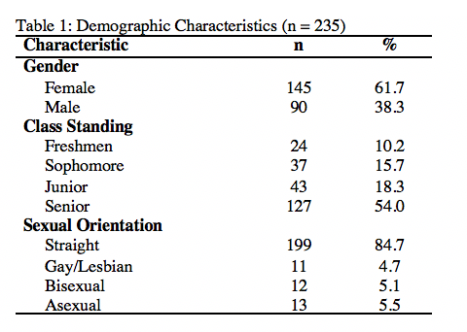

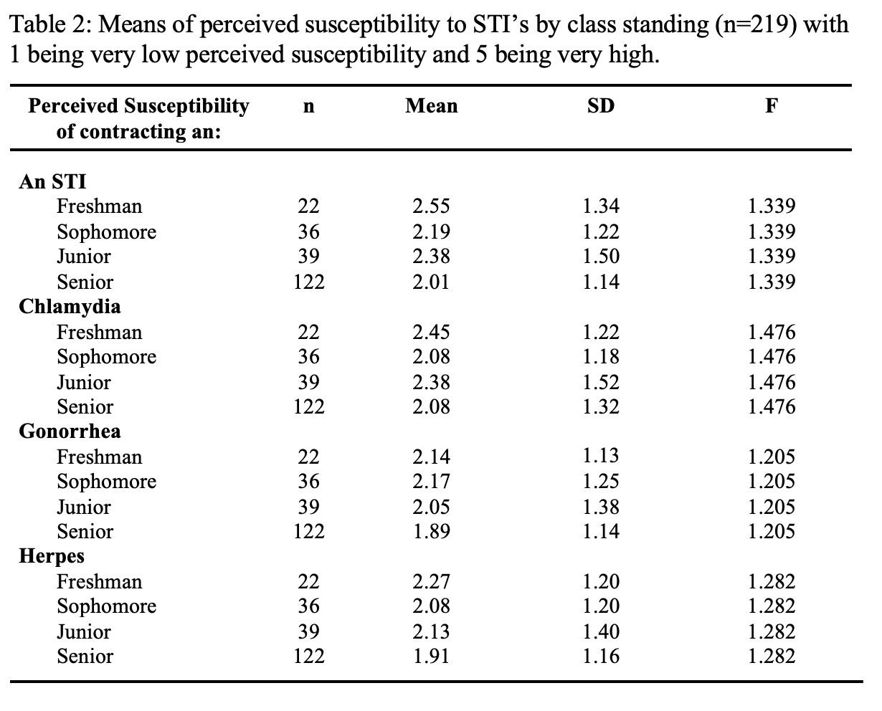
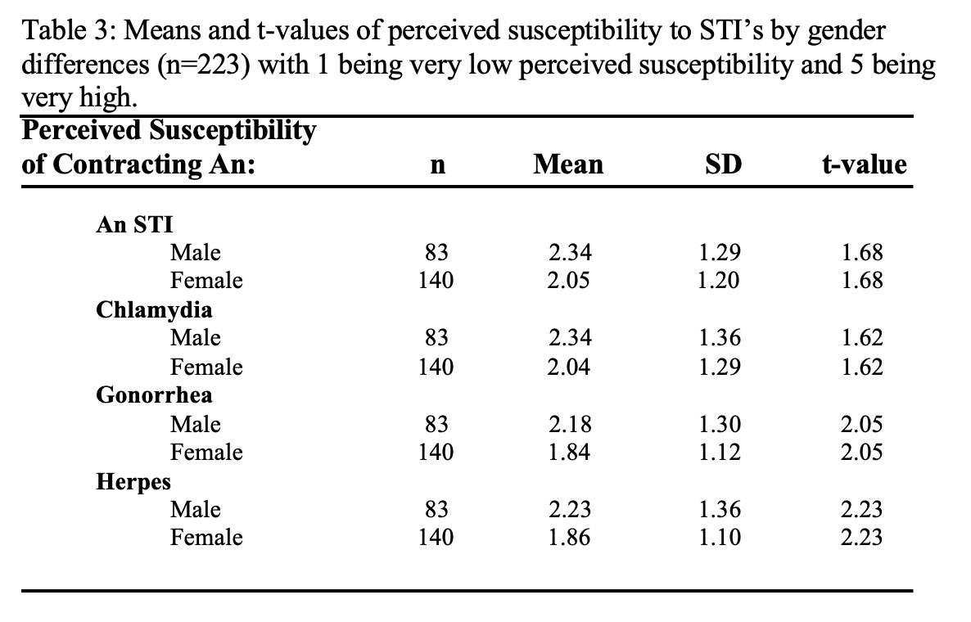

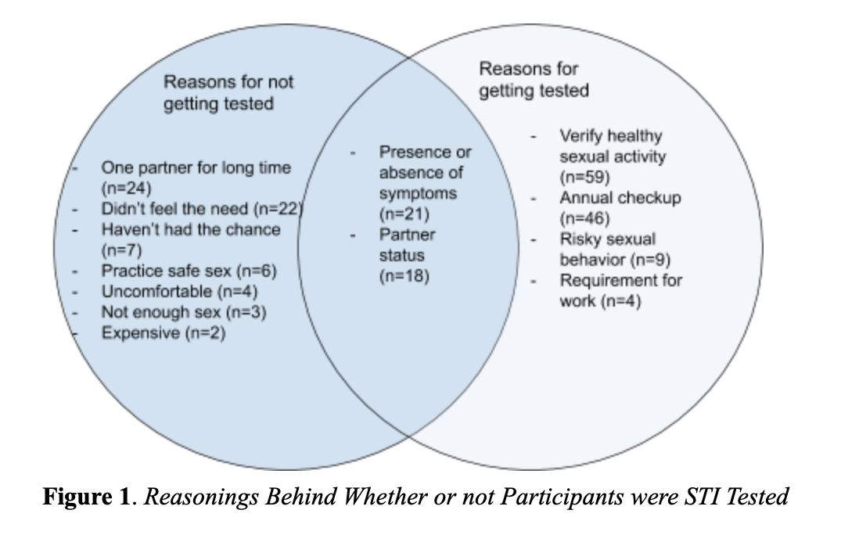

Appendix A – Final survey

Instructions: Please complete the first page to determine whether you are eligible to participate in the study.

1. What is your class standing? Pick the option that best describes your cumulative credit hours.
- Freshman (0-30 credits)
- Sophomore (31-60 credits)
- Junior (61-90 credits)
- Senior (91-120 credits)
- Other (please specify): ____

2. What is your gender? ________________

3. What is your sexual orientation? (ex: bisexual, asexual, etc.) _______________

Sexual Intercourse includes all of the below:

Vaginal sex (penis-in-vagina intercourse); Oral sex (mouth-to-genital contact); Anal sex (penis-in-anus intercourse)

4. Have you ever had sexual intercourse?
- Yes
- No

If the answer is no, you have completed the survey and can insert the survey into the envelope provided.

If you answered yes, please continue to the next page.

5. Have you had sexual intercourse in the past 6 months?
- Yes
- No

Sexual Partners

These include regular or casual partners that you have had sexual intercourse with.

6. How many sexual partners have you had in the past 6 months?
_____________

What is an STI?

Sexually transmitted infections (also known as STIs, or STDs for ‘sexually transmitted diseases,’ or VD for ‘venereal diseases’) are infections that are commonly/have a high probability of being spread from person to person through unprotected sexual intercourse. Examples are Chlamydia, Gonorrhea, Syphilis, Herpes and HIV.

7. Have you ever been tested for an STI?
- Yes, in the past year
- Yes, but not in the past year
- No

8. If yes, how many times have you been tested in the past year?
____________

9. In one to two sentences, please briefly tell us a little bit more about why you have or have not been tested for an STI.

What is a regular partner?
Someone you have a regular relationship with and with whom you have sexual intercourse. (ex: boyfriend/girlfriend, husband/wife)

What is a casual partner?

Someone you have sex with (once or several times), but with whom you have no regular relationship.

10. Please give a response to every question below by circling the correct answer.

In the past 12 months, have you…

Had VAGINAL sex with a REGULAR partner without a condom? | Yes | No
Had VAGINAL sex with a CASUAL partner without a condom? | Yes | No
Had ANAL sex with a REGULAR partner without a condom? | Yes | No
Had ANAL sex with a CASUAL partner without a condom? | Yes | No

11. Please indicate on the table below your response to the following questions.

 | Very low chance |  |  |  | Very high chance
Considering your answers above and what you know about STIs, what do you think your chances are of contracting an STI? | 1 | 2 | 3 | 4 | 5
Considering your answers above and what you know about STIs, what do you think your chances are of contracting Chlamydia? | 1 | 2 | 3 | 4 | 5
Considering your answers above and what you know about STIs, what do you think your chances are of contracting Gonorrhea? | 1 | 2 | 3 | 4 | 5
Considering your answers above and what you know about STIs, what do you think your chances are of contracting Herpes? | 1 | 2 | 3 | 4 | 5

Martin-Smith, H., A., Okpo, E., A., & Bull, E., R. (2018). Exploring psychosocial predictors of STI testing in university students. BMC Public Health, 18(664). https://doi.org/10.1186/s12889-018-5587-2.

Thank you for your time spent taking this survey. Please place your completed survey inside the envelope provided, seal it, and return it to the researcher.

