Before turning to the questions, please familiarize yourself with the variables in the data set. Below are descriptions of each scale and measure in the data set. The data were collected from Psychology majors only. All measures were collected at senior assessment, except for one measure, which was collected during the same participants’ freshman year.

· Demographics
o Gender
o Age
o Race (had to be categorized as “majority” and “minority” group members because of low numbers of minority groups represented)
o Sexual orientation (limited classification—Heterosexual, Homosexual, Bisexual/Other)
o GPA (senior GPA)

· Social Dominance Orientation (SDO): it is a measure of an individual's preference for hierarchy within any social system and the domination over lower-status groups. Scale has 2 subscales and one total score. Items are answered on a 7-point Likert scale and scores are averages on a 7-point scale.
o SDO Anti-egalitarianism: Higher scores indicate that participant is less likely to agree with social equality as a good cultural goal. (e.g., We shouldn't try to guarantee that every group has the same quality of life.)
o SDO Dominance: Higher scores indicate that participant is agrees that certain groups should dominate others in society. (e.g, Some groups of people are simply inferior to other groups.)
o SDO total: Higher scores indicate that participants endorse a social dominance orientation. (e.g., Inferior groups should stay in their place.)

· Multicultural Experiences Questionnaire (MEQ): 15-item (7-point scale), that measures multicultural experience and attitudes. Scale has 2 subscales and a total score. Higher scores indicate more multicultural experiences and more desire for multicultural experiences.
o Multicultural Experience: represents the number of multicultural experiences a person has had. (e.g., I work with people with cultural-racial-ethnic backgrounds different from my own)
o Multicultural Desire: represents the person’s effort or desire to increase their multicultural experiences. (e.g., I want to learn or am learning to speak another language)

· Color-Blind Racial Attitudes Scale (COBRAS): 20 item measure (6-point scale), that measures individuals’ color-blind racial attitudes. Comprised of 3 subscales.
o COBRAS racial privilege: Higher scores indicate that participant discounts white privilege (e.g., “Race plays an important role in who gets sent to prison”)
o COBRAS institutional discrimination: Higher scores indicate that participant discounts institutional discrimination and racism. (e.g., “Immigrants should try to fit into the culture and values of the U.S.”)
o COBRAS Blatant racial issues: Higher scores indicate that participant discounts racism as a part of the cultural. (e.g., “Racism may have been a problem in the past, it is not an important problem today.”)

· Monroe Multicultural Attitudes Scale Questionnaire (MASQUE): 18 item measure that measures an individuals knowledge of multicultural issues, interest in acting to improve multicultural awareness, and how much they care about multicultural awareness. Higher scores indicate more knowledge, care, and action. (e.g., “I realize that racism exists.)
o Pre test: Participants took the MASQUE during freshman year
o Post test: Participants took the MASQUE senior year

· Narcissism: 14-item measure, dichotomous choice where scores could range from 14 (lowest level of narcissism) to 28 (highest level of narcissism) (e.g., I like to look at myself in the mirror. Or I am not particularly interested in looking at myself in the mirror.)

· Empathy: 14-item scale where higher scores mean greater empathy (e.g., Before criticizing somebody, I try to imagine how I would feel if I were in their place)

· Climate Change Denial: Measure describes the extent to which a participant denies climate change as a scientifically valid phenomenon. Higher scores indicate greater denial of climate change (e.g., “The so called "Climate threat" is exaggerated” and “The seriousness of climate change is exaggerated in media.”)

For each of the following questions (where appropriate), (a) indicate the statistic you chose, (b) explain why you used that statistic, and (c) state your conclusion with regard to the original variables, including a statistical sentence. Make sure to include the necessary (d) tables from SPSS, and (e) graphs where indicated. Report means and standard deviations for your variables when appropriate.

1. Write a “participants” section. In the section, describe the sample of students included in the data set. You should include the number of students as well as appropriate demographic information, including gender, race, sexual orientation, and GPA. Report frequencies or averages, whichever is relevant. (10 pts)

The data used was collected from 107 Psychology majors. Of the 107 total participants, 85 were female and 21 were male, and one student did not disclose his or her gender. 86 classified themselves as white or caucasian and 21 participants classified themselves as a minority group member. Furthermore, 94 identify as heterosexual while 13 identity as homosexual. The majority of the participants (104) are seniors with only two holding a junior class status and one being a graduate student. The age of each participant ranged from 20-38 years old. Five students are 20 years old, 52 are age 21, 39 are age 22, four are 23, one is 24, two are age 25, one student is 26 years old, one is 32, one is 34, and one is 38 years old. The mean GPA for the participants is 3.28 and the standard deviation is 0.37.

2. Run descriptive statistics for GPA, SDOtotal, and Empathy. Make sure to save standardized values. Look at your data sheet. You should have 3 new columns. Explain what each of these columns means. Look at subject #14. Interpret his/her standardized SDO score. For subject #34, interpret his/her standardized empathy score. For subject #56, did he/she score higher on empathy or GPA? Explain. (10 pts)

The three new columns on the data sheet represent the z-scores for the variables GPA, SDOtotal, and empathy. Subject #14 has a standardized SDO score that is 0.835 standard deviations below the mean. Subject #34 has a standardized empathy score that is 0.018 standard deviations below the mean. Subject #56 scored higher on GPA because their z-score for GPA is 0.65 standard deviations above the mean, compared to their z-score for empathy which is 1.04 standard deviations below the mean.

3. Examine the relationships among the variable pairs below. Specifically, for each of the following relationships, a) construct a scatter plot, b) evaluate whether the relationship is linear or non-linear, c) compute the appropriate statistic, and d) write a sentence, including a statistical phrase, that interprets that statistic. (20 pts)
a. GPA & SDOtotal

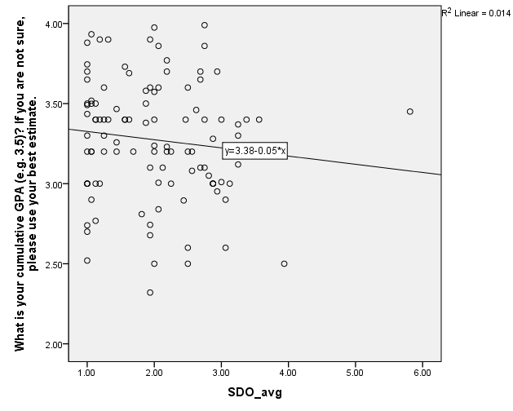

b) Non-linear relationship
c) The appropriate statistic for this relationship is a Pearson’s r correlation, r= -0.117, p= 0.234
d) There is a weak negative correlation between GPA and Social Dominance Orientation total (SDOtotal), but the relationship is not significant because the p-value is greater than .05.

Correlations
 |  | What is your cumulative GPA (e.g. 3.5)? If you are not sure, please use your best estimate. | SDO_avg
What is your cumulative GPA (e.g. 3.5)? If you are not sure, please use your best estimate. | Pearson Correlation | 1 | -.117
 | Sig. (2-tailed) |  | .234
 | N | 106 | 106
SDO_avg | Pearson Correlation | -.117 | 1
 | Sig. (2-tailed) | .234
 | N | 106 | 107

b. SDOtotal & Empathy

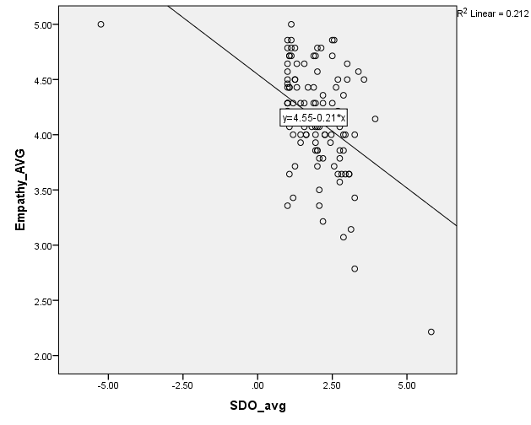

b) Linear relationship
c) The appropriate statistic for this relationship is a Pearson’s r correlation, r= -0.460, p < .000
d) There is a moderate negative correlation between empathy and SDOtotal and the relationship is significant because the p-value is less than .05. As empathy decreases, SDOtotal tends to increase.

Correlations
 |  | SDO_avg | Empathy_AVG
SDO_avg | Pearson Correlation | 1 | -.460**
 | Sig. (2-tailed) |  | .000
 | N | 107 | 107
Empathy_AVG | Pearson Correlation | -.460** | 1
 | Sig. (2-tailed) | .000
 | N | 107 | 107
**. Correlation is significant at the 0.01 level (2-tailed).

c. SDOtotal & CCD

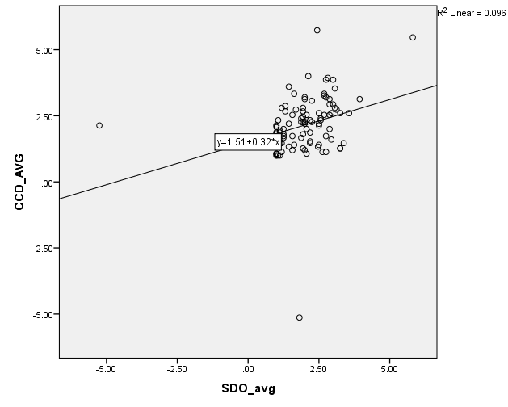
b) Linear relationship
c) The appropriate statistic for this relationship is a Pearson’s r correlation, r= 0.310, p= .001
d) There is a moderate positive correlation between SDOtotal and CCD and the relationship is significant because the p-value is less than .05. This means that as Social Dominance Orientation total increases, Climate Change Denial tends to increase as well.

Correlations
 |  | SDO_avg | CCD_AVG
SDO_avg | Pearson Correlation | 1 | .310**
 | Sig. (2-tailed) |  | .001
 | N | 107 | 105
CCD_AVG | Pearson Correlation | .310** | 1
 | Sig. (2-tailed) | .001
 | N | 105 | 105
**. Correlation is significant at the 0.01 level (2-tailed).

d. Age & Narcissism

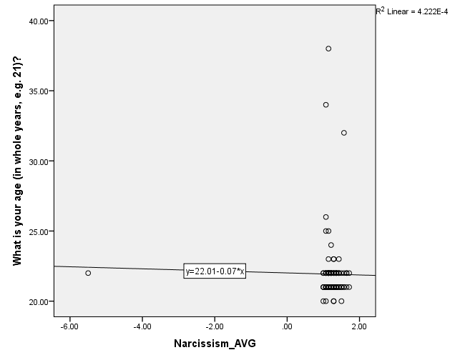

b) Non-linear relationship
c) The appropriate statistic for this relationship is a Pearson’s r correlation, r= -0.021, p= .834
d) Age and narcissism are not correlated in this example because the relationship is very weak. There is no significant relationship because the p-value is greater than .05.
Age and narcissism are negatively correlated in the adult population. However, they are not correlated here. Examine your data, including the distribution and descriptives, and give a reason why we might not have a correlation for this particular data set.
There is no relationship between age and narcissism in this example. One possible reason for this is that most of the participants are the same age. The ages range from 20-38 but the majority of the participants are 21 and 22 years old.

Correlations
 |  | What is your age (in whole years, e.g. 21)? | Narcissism_AVG
What is your age (in whole years, e.g. 21)? | Pearson Correlation | 1 | -.021
 | Sig. (2-tailed) |  | .834
 | N | 107 | 107
Narcissism_AVG | Pearson Correlation | -.021 | 1
 | Sig. (2-tailed) | .834
 | N | 107 | 107

4. Are men and women different on: a) empathy, b) narcissism, c) MEQ, or d) SDO anti-egalitarian measures? Make sure to explain each of these results separately. Include graphs for any significant differences. (20 pts)

I will use an independent samples t-test because we are comparing two groups (men and women) and the groups are not related to each other.

- Empathy

Group Statistics
 | Gender | N | Mean | Std. Deviation | Std. Error Mean
Empathy_AVG | Male | 21 | 3.8741 | .50955 | .11119
 | Female | 85 | 4.2155 | .46670 | .05062

Independent Samples Test
 |  | Levene's Test for Equality of Variances |  | t-test for Equality of Means
 |  | F | Sig. | t | df | Sig. (2-tailed) | Mean Difference | Std. Error Difference | 95% Confidence Interval of the Difference
 |  |  |  |  |  |  |  |  | Lower | Upper
Empathy_AVG | Equal variances assumed | .344 | .559 | -2.948 | 104 | .004 | -.34136 | .11581 | -.57102 | -.11171
 | Equal variances not assumed |  |  | -2.794 | 28.854 | .009 | -.34136 | .12217 | -.59129 | -.09144

Equal variances are assumed because the p-value for Levene’s Test for Equality of Variances is greater than .05. Under equal variances assumed, the p-value is .004, which is significant because it is less than .05. Therefore, we can reject the null hypothesis and conclude that the empathy scores between men and women are different and due to real population differences. On average, males have a lower empathy score than females with a mean difference of -0.34. Those who were male (M= 3.87, SD= 0.51) had significantly lower empathy scores than females (M= 4.22, SD= 0.47), t= -2.95, p= .004.

b) Narcissism

Group Statistics
 | Gender | N | Mean | Std. Deviation | Std. Error Mean
Narcissism_AVG | Male | 21 | .9116 | 1.47494 | .32186
 | Female | 85 | 1.2714 | .18003 | .01953

Independent Samples Test
 |  | Levene's Test for Equality of Variances |  | t-test for Equality of Means
 |  | F | Sig. | t | df | Sig. (2-tailed) | Mean Difference | Std. Error Difference | 95% Confidence Interval of the Difference
 |  |  |  |  |  |  |  |  | Lower | Upper
Narcissism_AVG | Equal variances assumed | 10.400 | .002 | -2.215 | 104 | .029 | -.35986 | .16248 | -.68206 | -.03767
 | Equal variances not assumed |  |  | -1.116 | 20.147 | .278 | -.35986 | .32245 | -1.03217 | .31244

Equal variances are not assumed because the p-value for Levene’s test is less than .05. The p-value for equal variances not assumed is 0.278, which is greater than .05. As a result, we have failed to reject the null hypothesis, meaning that there is no significant difference between men and women when it comes to narcissism scores and any difference seen is due to chance. Those who were male (M= 0.91, SD= 1.47) did not have significantly different scores than females (M= 1.27, SD= 0.18), t= -1.12, p= 0.278.

c) Multicultural Experiences Questionnaire

Group Statistics
 | Gender | N | Mean | Std. Deviation | Std. Error Mean
MEQ_Total | Male | 21 | 52.6190 | 7.25587 | 1.58336
 | Female | 85 | 39.0471 | 30.49899 | 3.30808

Independent Samples Test
 |  | Levene's Test for Equality of Variances |  | t-test for Equality of Means
 |  | F | Sig. | t | df | Sig. (2-tailed) | Mean Difference | Std. Error Difference | 95% Confidence Interval of the Difference
 |  |  |  |  |  |  |  |  | Lower | Upper
MEQ_Total | Equal variances assumed | 4.701 | .032 | 2.018 | 104 | .046 | 13.57199 | 6.72433 | .23739 | 26.90658
 | Equal variances not assumed |  |  | 3.701 | 103.977 | .000 | 13.57199 | 3.66748 | 6.29922 | 20.84476

Equal variances are not assumed because the p-value for Levene’s test is less than .05. Since the p-value in this example is less than .000, we can reject the null hypothesis. The Multicultural Experiences Questionnaire scores are significantly different for men and women and these differences are due to real population differences between the two groups. On average, males had a higher MEQ score than females with a mean difference of 13.57. Males (M= 52.62, SD= 7.26) also had significantly higher MEQ scores than females (M= 39.05, SD= 30.5), t= 3.701, p< .000.

d) SDO anti-egalitarianism

Group Statistics
 | Gender | N | Mean | Std. Deviation | Std. Error Mean
SDO_anti_egal_avg | Male | 21 | 2.5238 | 1.02135 | .22288
 | Female | 85 | 2.0250 | .97300 | .10554

Independent Samples Test
 |  | Levene's Test for Equality of Variances |  | t-test for Equality of Means
 |  | F | Sig. | t | df | Sig. (2-tailed) | Mean Difference | Std. Error Difference | 95% Confidence Interval of the Difference
 |  |  |  |  |  |  |  |  | Lower | Upper
SDO_anti_egal_avg | Equal variances assumed | .923 | .339 | 2.083 | 104 | .040 | .49881 | .23942 | .02403 | .97359
 | Equal variances not assumed |  |  | 2.023 | 29.620 | .052 | .49881 | .24660 | -.00509 | 1.00271

Equal variances are assumed because the p-value for Levene’s test is greater than .05. The p-value of .040 is less than .05 so the null hypothesis is rejected. We can conclude that the SDO anti-egalitarianism scores are significantly different between men and women and these are due to real population differences. On average, males have a higher SDO anti-egalitarianism score than females with a mean difference of .50. Males (M= 2.52, SD= 1.02) also had significantly higher SDO anti-egalitarianism scores than females (M= 2.03, SD= 0.97), t= 2.083, p= 0.040.

5. Are there differences between White/Majority members and Minority group members on either a) Narcissism or b) MEQ? Make sure to explain each of these results separately. Include graphs for any significant differences. (15 pts)

I would also use an independent samples t-test because we are comparing the scores between two groups (white/majority members and minority group members) that are unrelated to each other.

- Narcissism

Group Statistics
 | race/ethnicity? | N | Mean | Std. Deviation | Std. Error Mean
Narcissism_AVG | White or Caucasian | 86 | 1.2566 | .18379 | .01982
 | Minority | 21 | .9694 | 1.48574 | .32422

Independent Samples Test
 |  | Levene's Test for Equality of Variances |  | t-test for Equality of Means
 |  | F | Sig. | t | df | Sig. (2-tailed) | Mean Difference | Std. Error Difference | 95% Confidence Interval of the Difference
 |  |  |  |  |  |  |  |  | Lower | Upper
Narcissism_AVG | Equal variances assumed | 10.365 | .002 | 1.764 | 105 | .081 | .28726 | .16288 | -.03571 | .61023
 | Equal variances not assumed |  |  | .884 | 20.150 | .387 | .28726 | .32482 | -.38999 | .96450

Since the p-value of .002 is less than .05, equal variances are not assumed. The p-value of .387 is greater than .05, so we fail to reject the null hypothesis. As a result, the narcissism scores between the two groups are not significantly different and any perceived differences are due to chance. Those who were white/majority group members (M= 1.26, SD= 0.18) did not have significantly different scores compared to those who were minority group members (M= 0.97, SD= 1.49), t= 0.884, p= 0.387.

b) Multicultural Experiences Questionnaire

Group Statistics
 | race/ethnicity? | N | Mean | Std. Deviation | Std. Error Mean
MEQ_Total | White or Caucasian | 86 | 38.6047 | 30.15383 | 3.25157
 | Minority | 21 | 55.2381 | 5.17595 | 1.12949

Independent Samples Test
 |  | Levene's Test for Equality of Variances |  | t-test for Equality of Means
 |  | F | Sig. | t | df | Sig. (2-tailed) | Mean Difference | Std. Error Difference | 95% Confidence Interval of the Difference
 |  |  |  |  |  |  |  |  | Lower | Upper
MEQ_Total | Equal variances assumed | 5.978 | .016 | -2.510 | 105 | .014 | -16.63344 | 6.62660 | -29.77276 | -3.49413
 | Equal variances not assumed |  |  | -4.832 | 100.530 | .000 | -16.63344 | 3.44216 | -23.46215 | -9.80474

Since the p-value of .016 is less than .05, equal variances are not assumed. We can reject the null hypothesis because the p-value of .000 is less than .05. This means that the MEQ scores between the two groups is significantly different and due to real population differences. On average, the white/majority group had a lower MEQ score than the minority group, with a mean difference of -16.63. The white/majority group members (M= 38.60, SD= 30.15) had significantly lower scores than those who were minority group members (M= 55.24, SD= 5.18), t= -4.832, p= .000.

6. Can you predict Climate Change Denial (CCD) using Social Dominance Orientation (SDOtotal)? Make sure to include all relevant tables. (15 pts)
a. Explain R, R-squared, and the standard error of the estimate
b. Is this regression significant? How do you know? What does that mean?
c. Is the predictor significant? How do you know? What does that mean?

The statistic I will use for this problem is simple regression because I am predicting climate change denial using one predictor (social dominance orientation).

Model Summary
Model | R | R Square | Adjusted R Square | Std. Error of the Estimate
1 | .310ª | .096 | .087 | 1.09396
a. Predictors: (Constant), SDO_avg

ANOVAª
Model |  | Sum of Squares | df | Mean Square | F | Sig.
1 | Regression | 13.121 | 1 | 13.121 | 10.964 | .001^{b}
 | Residual | 123.264 | 103 | 1.197
 | Total | 136.385 | 104
a. Dependent Variable: CCD_AVG
b. Predictors: (Constant), SDO_avg

Coefficientsª
Model |  | Unstandardized Coefficients |  | Standardized Coefficients | t | Sig.
 |  | B | Std. Error | Beta
1 | (Constant) | 1.506 | .216 |  | 6.960 | .000
 | SDO_avg | .322 | .097 | .310 | 3.311 | .001
a. Dependent Variable: CCD_AVG

- R-squared is the proportionate reduction in error, 9.6% of the variance in CCD can be predicted by the variance in SDOtotal. The standard error of the estimate is 1.09, which is the average mistake made when using SDOtotal to predict CCD. The R value is .310 and it represents the correlation between SDOtotal and CCD. The value of .310 is the relationship between SDOtotal and CCD, which is a weak positive correlation.
- The regression is significant because the p-value is less than .05. We can conclude that the SDOtotal is a significant predictor of CCD.
- The predictor SDOtotal is also significant because it has a p-value that is less than .05. This means that SDOtotal is a significant predictor of CCD and we can reject the null hypothesis.

7. Can you predict CCD using SDOtotal, and the 3 COBRAS subscales (Racial Privilege, Institutional Discrimination, & Blatant Racial Issues)? Make sure to include all relevant tables. (20 pts)
a. Explain R, R-squared, and the standard error of the estimate
b. Is this regression significant? How do you know? What does that mean?
c. Are the predictors significant? How do you know? What does that mean?

I will use multiple regression for this problem because I am predicting climate change denial using more than one predictor (SDOtotal and the 3 COBRAS subscales).

Descriptive Statistics
 | Mean | Std. Deviation | N
CCD_AVG | 2.1289 | 1.14516 | 105
SDO_avg | 1.9173 | 1.09814 | 107
COBRAS_RP_AVG | 3.5634 | 1.57398 | 107
COBRAS_ID_AVG | 3.0096 | 2.01012 | 107
COBRAS_BRI_AVG | 5.1411 | .77483 | 107

Correlations
 |  | CCD_AVG | SDO_avg | COBRAS_RP_AVG | COBRAS_ID_AVG | COBRAS_BRI_AVG
CCD_AVG | Pearson Correlation | 1 | .310** | -.225* | -.014 | -.385**
 | Sig. (2-tailed) |  | .001 | .021 | .890 | .000
 | N | 105 | 105 | 105 | 105 | 105
SDO_avg | Pearson Correlation | .310** | 1 | -.082 | .044 | -.507**
 | Sig. (2-tailed) | .001 |  | .402 | .654 | .000
 | N | 105 | 107 | 107 | 107 | 107
COBRAS_RP_AVG | Pearson Correlation | -.225* | -.082 | 1 | .674** | .118
 | Sig. (2-tailed) | .021 | .402 |  | .000 | .226
 | N | 105 | 107 | 107 | 107 | 107
COBRAS_ID_AVG | Pearson Correlation | -.014 | .044 | .674** | 1 | -.085
 | Sig. (2-tailed) | .890 | .654 | .000 |  | .384
 | N | 105 | 107 | 107 | 107 | 107
COBRAS_BRI_AVG | Pearson Correlation | -.385** | -.507** | .118 | -.085 | 1
 | Sig. (2-tailed) | .000 | .000 | .226 | .384
 | N | 105 | 107 | 107 | 107 | 107
**. Correlation is significant at the 0.01 level (2-tailed).
*. Correlation is significant at the 0.05 level (2-tailed).

Model Summary
Model | R | R Square | Adjusted R Square | Std. Error of the Estimate
1 | .457ª | .209 | .177 | 1.03873
a. Predictors: (Constant), COBRAS_BRI_AVG, COBRAS_ID_AVG, SDO_avg, COBRAS_RP_AVG

ANOVAª
Model |  | Sum of Squares | df | Mean Square | F | Sig.
1 | Regression | 28.488 | 4 | 7.122 | 6.601 | .000^{b}
 | Residual | 107.897 | 100 | 1.079
 | Total | 136.385 | 104
a. Dependent Variable: CCD_AVG
b. Predictors: (Constant), COBRAS_BRI_AVG, COBRAS_ID_AVG, SDO_avg, COBRAS_RP_AVG

Coefficientsª
Model |  | Unstandardized Coefficients |  | Standardized Coefficients | t | Sig.
 |  | B | Std. Error | Beta
1 | (Constant) | 4.313 | .934 |  | 4.617 | .000
 | SDO_avg | .153 | .107 | .147 | 1.425 | .157
 | COBRAS_RP_AVG | -.203 | .089 | -.281 | -2.268 | .025
 | COBRAS_ID_AVG | .082 | .070 | .145 | 1.178 | .242
 | COBRAS_BRI_AVG | -.391 | .155 | -.265 | -2.513 | .014
a. Dependent Variable: CCD_AVG

- The R value is .457 and it represents the correlation between the predicted values and CCD. The value of .457 is a moderate positive correlation. R-squared is the proportionate reduction in error, 20.9% of variance in Climate Change Denial (CCD) can be predicted by the variance in SDOtotal, and the three COBRAS subscales (Racial Privilege, Institutional Discrimination, and Blatant Racial Issues). Standard error of the estimate can be interpreted as when using SDOtotal and the 3 COBRAS subscales to predict CCD, we are off on average by 1.04 points.
- The regression is significant because the p-value is below .05, which means that SDOtotal and the three COBRAS subscales are significant predictors of CCD.
- The SDOtotal predictor is not significant because its p-value (.157) is greater than .05, which means that SDOtotal is not a significant predictor of CCD scores. This also means that we fail to reject the null hypothesis. The COBRAS racial privilege predictor is significant because the p-value is .025, which is less than .05. This means that racial privilege is a significant predictor of CCD scores and we can reject the null hypothesis. The COBRAS institutional discrimination predictor is not significant since the p-value is .242, which is greater than .05. This means that institutional discrimination is not a significant predictor of CCD scores and we fail to reject the null hypothesis. The COBRAS blatant racial issues predictor is significant because it has a p-value of .014, which is less than .05. We can conclude that blatant racial issues are a significant predictor of CCD scores and we can reject the null hypothesis.

8. Examine gender (male & female) and race (majority & minority groups) differences in narcissism scores. Make sure to explain all of your results. Include all tables and an appropriate graph. (25 pts)

I will use the 2x2 between groups ANOVA because there are two factors and each factor has two levels.

Between-Subjects Factors
 |  | Value Label | N
Gender | 1 | Male | 21
 | 2 | Female | 85
race/ethnicity? | 1 | White or Caucasian | 85
 | 2 | Minority | 21

Tests of Between-Subjects Effects
Dependent Variable: Narcissism_AVG
Source | Type III Sum of Squares | df | Mean Square | F | Sig.
Corrected Model | 5.291ª | 3 | 1.764 | 4.171 | .008
Intercept | 55.881 | 1 | 55.881 | 132.181 | .000
gender | 3.276 | 1 | 3.276 | 7.749 | .006
race | 2.229 | 1 | 2.229 | 5.274 | .024
gender * race | 2.216 | 1 | 2.216 | 5.242 | .024
Error | 43.122 | 102 | .423
Total | 201.087 | 106
Corrected Total | 48.412 | 105
a. R Squared = .109 (Adjusted R Squared = .083)

Descriptive Statistics
Dependent Variable: Narcissism_AVG
Gender | race/ethnicity? | Mean | Std. Deviation | N
Male | White or Caucasian | 1.1837 | .12440 | 14
 | Minority | .3673 | 2.58838 | 7
 | Total | .9116 | 1.47494 | 21
Female | White or Caucasian | 1.2716 | .19190 | 71
 | Minority | 1.2704 | .10549 | 14
 | Total | 1.2714 | .18003 | 85
Total | White or Caucasian | 1.2571 | .18482 | 85
 | Minority | .9694 | 1.48574 | 21
 | Total | 1.2001 | .67902 | 106

Levene's Test of Equality of Error Variancesª
Dependent Variable: Narcissism_AVG
F | df1 | df2 | Sig.
24.663 | 3 | 102 | .000
Tests the null hypothesis that the error variance of the dependent variable is equal across groups.
a. Design: Intercept + gender + race + gender * race

The null hypothesis for gender is that the population mean score for narcissism is equal for both males and females. The research hypothesis is that the two population means are not equal. The null hypothesis for race is that the population mean score for narcissism is equal for both majority and minority groups. The research hypothesis for race is that the two population means are not equal for majority and minority groups. The null hypothesis states that there is not an interaction between gender and race and the research hypothesis states that there is an interaction between gender and race. The p-value for Levene’s Test of Equality of Error Variance is less than .000 which is less than .05. As a result, we rejected the null hypothesis and concluded that the population mean scores for narcissism are not equal.

Estimates
Dependent Variable: Narcissism_AVG
Gender | Mean | Std. Error | 95% Confidence Interval
 |  |  | Lower Bound | Upper Bound
Male | .776 | .150 | .477 | 1.074
Female | 1.271 | .095 | 1.082 | 1.460

Estimates
Dependent Variable: Narcissism_AVG
race/ethnicity? | Mean | Std. Error | 95% Confidence Interval
 |  |  | Lower Bound | Upper Bound
White or Caucasian | 1.228 | .095 | 1.039 | 1.416
Minority | .819 | .150 | .520 | 1.117

3. Gender * race/ethnicity?
Dependent Variable: Narcissism_AVG
Gender | race/ethnicity? | Mean | Std. Error | 95% Confidence Interval
 |  |  |  | Lower Bound | Upper Bound
Male | White or Caucasian | 1.184 | .174 | .839 | 1.528
 | Minority | .367 | .246 | -.120 | .855
Female | White or Caucasian | 1.272 | .077 | 1.119 | 1.425
 | Minority | 1.270 | .174 | .926 | 1.615

I ran a 2x2 between-subjects ANOVA with narcissism scores as the dependent variable and gender and race as the independent variables. The results showed a significant main effect for gender, F(1,102)= 7.749, p< .05, partial eta-squared= .071, with males (M= 0.91, SD= 1.47) scoring significantly lower than females (M=1.27, SD=.18). There was also a significant main effect for race, F(1,102)= 5.274, p< .05, partial eta-squared= 0.049, with the majority group members (M= 1.26, SD= 0.18) scoring significantly higher than the minority group members (M= 0.97, SD= 1.49). There was also a significant interaction between gender and race, F(1,102)= 5.242, p< .05, partial eta-squared= 0.049.

9. Did students change on their MASQUE scores from freshman year to senior year? Explain your results. Make sure to include all tables and a graph. (FYI, you might need help with the graph). (15 pts)

The best statistic to use for this problem is a dependent samples t-test because we are comparing two groups that are related to each other.

